Ideation Phase
Brainstorm & Idea Prioritization Template

Date | 22 December 2025
Team ID
Project Name | MediConnect
Maximum Marks | 4 Marks

Brainstorm & Idea Prioritization Template:

Overview:
The Brainstorm & Idea Prioritization phase focuses on generating innovative solutions to address the challenges faced by patients and healthcare providers in appointment management. Through collaborative brainstorming, the team explored multiple ideas and evaluated them based on impact and feasibility to define the most effective features for the MediConnect platform.
Step-1: Team Gathering, Collaboration and Select the Problem Statement

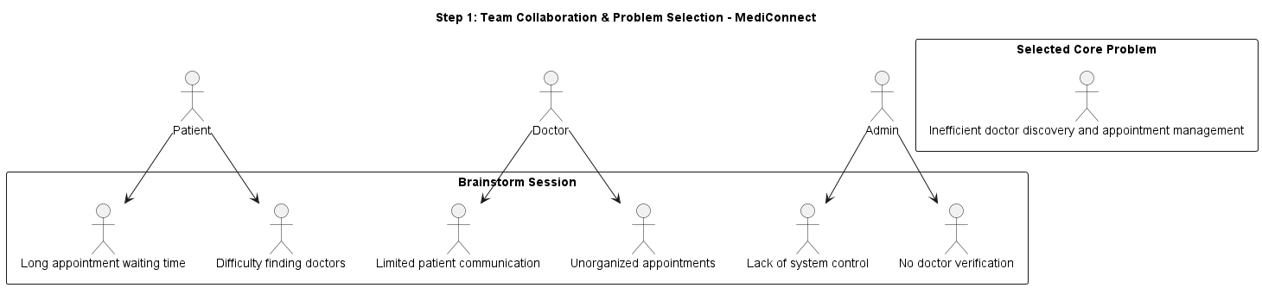

Step-2: Brainstorm, Idea Listing and Grouping

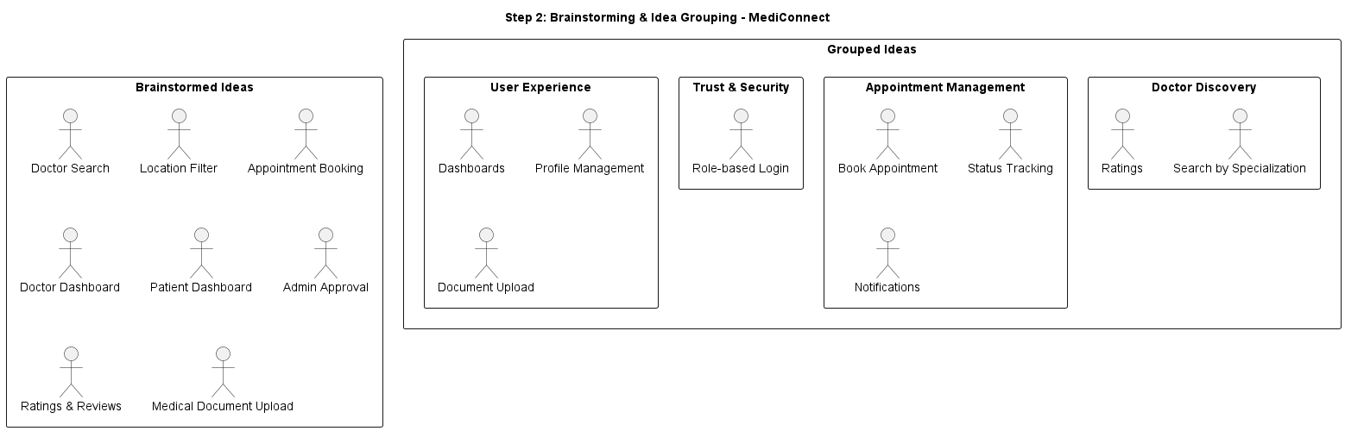

Step-3: Idea Prioritization

